Name:-Burka Fikadu

Project title

Explainable Artificial Intelligence (XAI)
Explainable Artificial Intelligence (XAI) is one of the most important developments in modern technology.
As Artificial Intelligence systems become deeply integrated into healthcare, finance, transportation, education, agriculture, and cybersecurity, people increasingly need to understand how these systems make decisions.
Traditional AI systems often work like “black boxes,” where users only see the final output without understanding the reasoning behind it.
XAI solves this problem by making AI systems more transparent, understandable, accountable, and trustworthy.

1. Introduction to Artificial Intelligence
Artificial Intelligence (AI) refers to computer systems that can perform tasks that normally require human intelligence.
These tasks include learning, reasoning, problem-solving, speech recognition, language understanding, decision-making, and pattern recognition.
AI technologies are rapidly transforming the world by improving automation, efficiency, and accuracy.
AI is commonly divided into several categories. Narrow AI focuses on performing a single task, such as facial recognition or recommendation systems.
General AI, which is still under development, aims to perform any intellectual task that a human can do.
Machine Learning and Deep Learning are important subfields of AI that allow systems to learn from large amounts of data.
Today, AI is used in hospitals to detect diseases, in banks to identify fraud, in schools to personalize learning, and in cybersecurity to detect attacks.
Despite these benefits, many AI systems are difficult to understand because of their complexity. This challenge created the need for Explainable AI.

2. What is Explainable Artificial Intelligence (XAI)?
Explainable Artificial Intelligence (XAI) is a branch of AI that focuses on creating systems whose decisions and actions can be clearly understood by humans.
XAI helps users know why a decision was made, which factors influenced the result, and how confident the system is about its prediction.
For example, if an AI system predicts that a patient may have diabetes, XAI can explain that the prediction was based on blood sugar level, age, body weight, and family history.
This explanation increases trust and helps doctors make informed decisions.
The goal of XAI is not only to improve AI performance but also to ensure fairness, accountability, transparency, ethics, and responsible use of technology.

3. The Growing Importance of Explainable AI
Artificial Intelligence is rapidly transforming industries around the world. As AI systems become more powerful and complex, there is a growing demand for transparency and accountability.
Explainable AI ensures that humans remain in control of intelligent systems by allowing users to understand how decisions are made.
Governments, businesses, schools, and hospitals increasingly require AI systems to provide clear explanations before they can be trusted.
The growing use of AI in critical areas such as healthcare, banking, and law enforcement makes explainability extremely important.
For example, if an AI system recommends medical treatment or rejects a loan application, users need to know the reasons behind the decision.
Without explanations, people may lose trust in AI technologies. Future advancements in AI will likely focus on balancing performance, fairness, transparency, and ethics.
Developing countries such as Ethiopia can greatly benefit from responsible AI adoption in agriculture, healthcare, education, and digital finance.

4. Importance of Explainable AI
Explainable AI is important because people need to trust technology before using it in critical situations.
In healthcare, doctors must understand AI recommendations before treating patients. In banking, customers need to know why loans are approved or rejected.
XAI improves transparency by allowing organizations to explain automated decisions. It also helps identify bias and discrimination in AI models.
For example, if a hiring system unfairly favors one group over another, XAI techniques can help experts identify and correct the bias.
Another major importance of XAI is legal compliance. Many countries now require organizations to explain automated decisions that affect people’s lives.

4. Real-Life Applications of Explainable AI

(XAI)
Healthcare: XAI helps doctors understand disease prediction systems and improves patient trust.
Banking: Financial institutions use XAI to explain loan approval systems and fraud detection.
Education: Schools and universities use XAI to identify struggling students and recommend personalized support.
Cybersecurity: XAI explains suspicious activities, malware detection, and unusual login attempts.
Transportation: Self-driving vehicles use XAI to explain navigation and safety decisions.
Agriculture: Farmers can use XAI systems to understand weather predictions, soil analysis, and crop disease recommendations.
- Explainable AI in Healthcare
Healthcare is one of the most important sectors benefiting from Explainable AI. Hospitals and healthcare organizations use AI systems to diagnose diseases, predict medical conditions, and recommend treatments.
However, doctors and patients need to understand how these systems make decisions. For instance, if an AI system predicts that a patient has diabetes, XAI can explain that the prediction was influenced by blood sugar levels, family history, weight, and lifestyle habits.
This transparency improves trust between healthcare workers and AI systems. In developing countries like Ethiopia, Explainable AI can help healthcare workers in rural areas where medical specialists are limited.
AI-powered tools can support doctors in diagnosing diseases while still allowing humans to verify the recommendations.
- Explainable AI in Education
Education systems are increasingly using Artificial Intelligence to improve learning experiences. AI systems can analyze student performance, identify weak areas, and recommend personalized learning strategies.
Explainable AI helps teachers and students understand why certain recommendations are made. For example, if a student is predicted to fail a course, the AI system can explain that poor attendance, low assignment scores, or lack of participation contributed to the prediction.
This transparency allows teachers to provide targeted support and helps students improve their performance.
In Ethiopia, where access to educational resources may vary across regions, XAI can help create fair and personalized educational opportunities.
- Explainable AI in Banking and Finance
Banks and financial institutions use AI systems for fraud detection, loan approval, customer analysis, and financial forecasting.
Explainable AI ensures that these decisions are fair, transparent, and understandable. For example, if a customer’s loan application is rejected, XAI can explain the reasons, such as low income, poor credit history, or incomplete documentation.
This improves customer trust and reduces confusion. XAI also helps detect fraud by identifying suspicious transactions and explaining why they are considered risky. As digital banking grows in Ethiopia, Explainable AI can improve financial inclusion and cybersecurity protection.
- Explainable AI in Agriculture
Agriculture is the backbone of Ethiopia’s economy, and Explainable AI can significantly improve agricultural productivity.
AI systems can analyze weather patterns, soil conditions, crop diseases, and irrigation systems to help farmers make informed decisions.
Explainable AI allows farmers to understand why certain recommendations are made. For example, an AI system may recommend planting a specific crop based on rainfall predictions and soil quality.
Farmers are more likely to trust the system when they understand the reasoning behind the recommendation. XAI can also support food security, reduce crop losses, and improve agricultural planning in rural communities.
- Explainable AI and Cybersecurity
Cybersecurity systems increasingly rely on AI to detect malware, hacking attempts, and suspicious online activities. However, cybersecurity experts need to understand why an AI system identifies certain behaviors as threats.
Explainable AI provides detailed explanations about suspicious activities, unusual login attempts, or dangerous software behavior. This helps experts respond quickly and accurately to cyber threats.
As internet usage continues to grow in Ethiopia and other developing countries, XAI can strengthen digital security and reduce cybercrime risks.

5. Explainable AI Techniques
Decision Trees provide step-by-step reasoning paths that humans can easily follow.
LIME (Local Interpretable Model-Agnostic Explanations) explains individual predictions by simplifying complex models locally.
SHAP (SHapley Additive exPlanations) measures how much each feature contributes to the final prediction.
Rule-Based Systems use logical rules that humans can understand.
Attention Visualization highlights important parts of input data used by deep learning systems.

6. Future of Explainable AI in Ethiopia
Ethiopia is rapidly adopting digital technologies in many sectors. Explainable AI can significantly support national development.
In agriculture, AI systems can predict weather conditions, identify crop diseases, and improve productivity.
XAI allows farmers to understand why recommendations are given.
In healthcare, XAI can support rural clinics by assisting healthcare workers in diagnosing diseases.
In education, AI systems can monitor student performance and recommend personalized learning methods.
In banking, XAI can improve transparent digital financial services and fraud detection.
Government institutions can also use XAI in traffic management, tax systems, and public resource allocation.

7. Advantages of Explainable AI

- Builds Trust and User Confidence

One of the biggest advantages of explainable AI is that it builds trust between users and technology. People are more likely to use AI systems when they understand how decisions are made. If an AI system provides recommendations without explanation, users may doubt its reliability. However, when the system explains why a decision was made, users gain confidence in the output.
For example, if an AI system in a bank rejects a loan application, explainable AI can show the factors that influenced the decision, such as income level, credit history, or repayment ability. This transparency helps customers trust the process.
- Improves Decision-Making
Explainable AI supports better human decision-making because users can analyze and evaluate the AI’s reasoning before taking action. Instead of blindly accepting AI outputs, humans can combine their own knowledge and experience with AI recommendations.
In healthcare, doctors can use explainable AI to understand why an AI system predicts a disease. The AI may identify unusual patterns in medical scans and explain the important features it used. Doctors can then verify the information and make more accurate treatment decisions.
- Detects Errors and Bias
AI systems can sometimes make mistakes or produce unfair results because of biased training data or incorrect algorithms. Explainable AI helps developers and users identify these problems more easily.
For example, if a recruitment AI system unfairly favors certain applicants, explainable AI can reveal which factors influenced the hiring recommendation. Developers can then adjust the model to reduce discrimination and improve fairness.
This advantage is very important because biased AI can negatively affect people’s lives in education, employment, banking, and law enforcement.
- Increases Transparency and Accountability
Explainable AI makes organizations more transparent about how they use technology. When AI systems affect important decisions, companies and institutions must be accountable for the outcomes.
Transparency is essential in industries such as:
Finance
Healthcare
Government services
Education
Security systems
If an AI system makes a mistake, explainable AI helps identify the reason behind the error. This allows organizations to take responsibility and improve their systems.
- Enhances Safety and Reliability
In critical systems, explainable AI improves safety by allowing experts to confirm whether the AI is functioning correctly. In areas like self-driving cars, medical diagnosis, and cybersecurity, wrong decisions can be dangerous.
For instance, in autonomous vehicles, explainable AI can help engineers understand why a car decided to stop, turn, or avoid an obstacle. This makes testing and improving the system easier and safer.
- Supports Ethical AI Development
Ethics is becoming increasingly important in artificial intelligence. Explainable AI promotes ethical use of technology by ensuring fairness, honesty, and respect for human rights.
Many people worry that AI systems may secretly manipulate decisions or unfairly treat certain groups. Explainable AI reduces these concerns because users can examine how decisions are made and whether the system follows ethical standards.
- Helps Meet Legal and Regulatory Requirements
Many countries and organizations now require AI systems to be transparent and understandable. Explainable AI helps companies comply with laws and regulations related to privacy, fairness, and accountability.
For example, some data protection laws require organizations to explain automated decisions that affect individuals. Explainable AI helps organizations provide these explanations clearly.
- Encourages Human-AI Collaboration
Explainable AI creates better cooperation between humans and machines. Instead of replacing humans completely, explainable AI assists people by providing understandable insights and recommendations.
Teachers, doctors, engineers, and business managers can work together with AI systems more effectively when they understand how the technology operates. This improves productivity and decision quality.
- Improves AI Education and Research
Students and researchers benefit from explainable AI because it helps them understand how machine learning models function. By studying explanations, learners can better understand concepts such as:
Data processing
Neural networks
Decision trees
Prediction models
Pattern recognition
This supports innovation and further development in artificial intelligence research.

8. Challenges of Explainable AI
Despite its benefits, XAI faces several challenges. Some AI models are extremely complex and difficult to explain.
Explanations may also be too technical for ordinary users.
Another challenge is the trade-off between explainability and performance.
Sometimes highly accurate AI models are harder to interpret.
Developing explainable systems also requires skilled experts, financial resources, and advanced tools.
Despite its advantages, Explainable AI faces several challenges. Some AI models are extremely complex and difficult to interpret.
Deep learning systems, for example, may contain millions of parameters that are difficult for humans to understand.
Another challenge is balancing explainability and accuracy. Highly explainable systems may sometimes sacrifice prediction performance, while highly accurate systems may be less transparent.
Additionally, explanations may be too technical for ordinary users. Organizations must therefore create explanations that are both accurate and easy to understand.

9. Ethical Issues in AI
Ethics is an important topic in Artificial Intelligence. AI systems must avoid discrimination, protect privacy, and ensure fairness.
Organizations should use AI responsibly to avoid harmful consequences.
XAI supports ethical AI by helping people understand how decisions are made and by increasing accountability.
.AI systems must avoid discrimination, protect privacy, and ensure fairness in decision-making. Explainable AI supports ethical AI development by making decisions more transparent and accountable.
For example, if an AI hiring system unfairly favors one group over another, XAI techniques can help identify the source of bias.
Organizations developing AI technologies must ensure that systems are fair, reliable, and respectful of human rights.
This is especially important when AI systems affect people’s education, employment, healthcare, or financial opportunities.

10. The Future of Explainable AI

The future of Explainable AI looks very promising. Researchers and technology companies are investing heavily in creating AI systems that are transparent, fair, and trustworthy.
Future AI systems will likely include built-in explanation features that allow users to understand decisions in real time. Governments may also create laws requiring organizations to explain AI decisions that affect people’s lives.
As AI technologies continue to evolve, Explainable AI will become essential for ensuring responsible and ethical innovation across the world.

10. Conclusion
Explainable Artificial Intelligence is becoming essential in the digital world.
As AI systems continue to influence healthcare, education, banking, cybersecurity, transportation, and government services, humans must understand how these systems operate.
XAI improves trust, transparency, fairness, and accountability.
Countries like Ethiopia can greatly benefit from XAI in agriculture, healthcare, education, finance, and cybersecurity.
The future of AI will depend not only on creating powerful systems but also on creating systems that humans can understand, trust, and use responsibly.

11. Graph: Future Impact of Explainable AI in Ethiopia
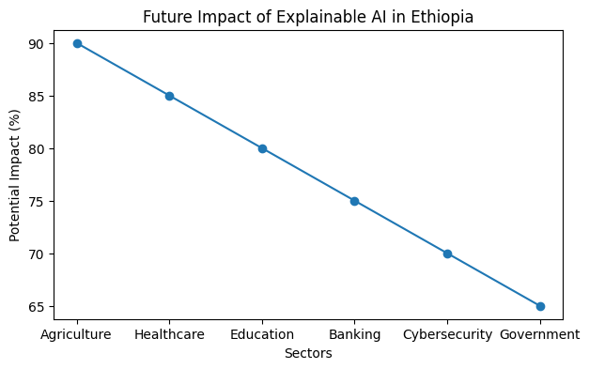

12. Chart: Benefits of Explainable AI
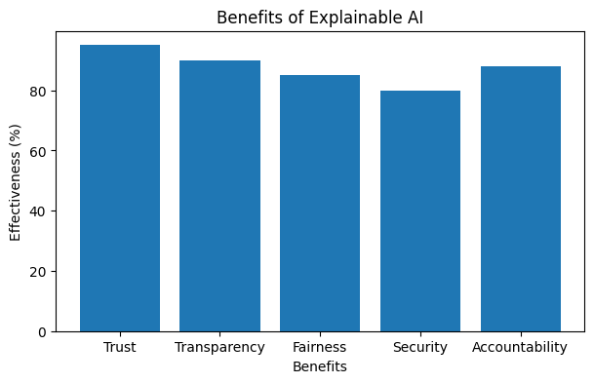

13. Summary Table
Sector | Possible Use | Benefit
Healthcare | Disease Prediction | Improves diagnosis
Agriculture | Crop Monitoring | Increases productivity
Education | Student Analysis | Improves learning
Banking | Fraud Detection | Improves security
Government | Public Services | Better transparency

